Experiment 4

Exploratory Data Analysis (EDA) – Data Inspection, Filtering, Statistical Analysis and Correlation

Aim

To perform data inspection, filtering, sorting, grouping, aggregation, descriptive statistical analysis, and correlation analysis using Pandas and visualize the results using Matplotlib on the Player Dataset.

Procedure
- Import the required Python libraries.
- Load the Player dataset into a Pandas DataFrame.
- Inspect the dataset by displaying sample records, dimensions, and data types.
- Convert the birthday column into datetime format and extract Year, Month, Day, and Hour.
- Filter records based on height and weight.
- Sort the dataset using weight.
- Calculate descriptive statistics such as mean, median, mode, and standard deviation.
- Group the dataset by Year and calculate the average height and weight.
- Perform correlation analysis among numerical attributes.
- Visualize the grouped results and correlation matrix
- Interpret the obtained analytical results.

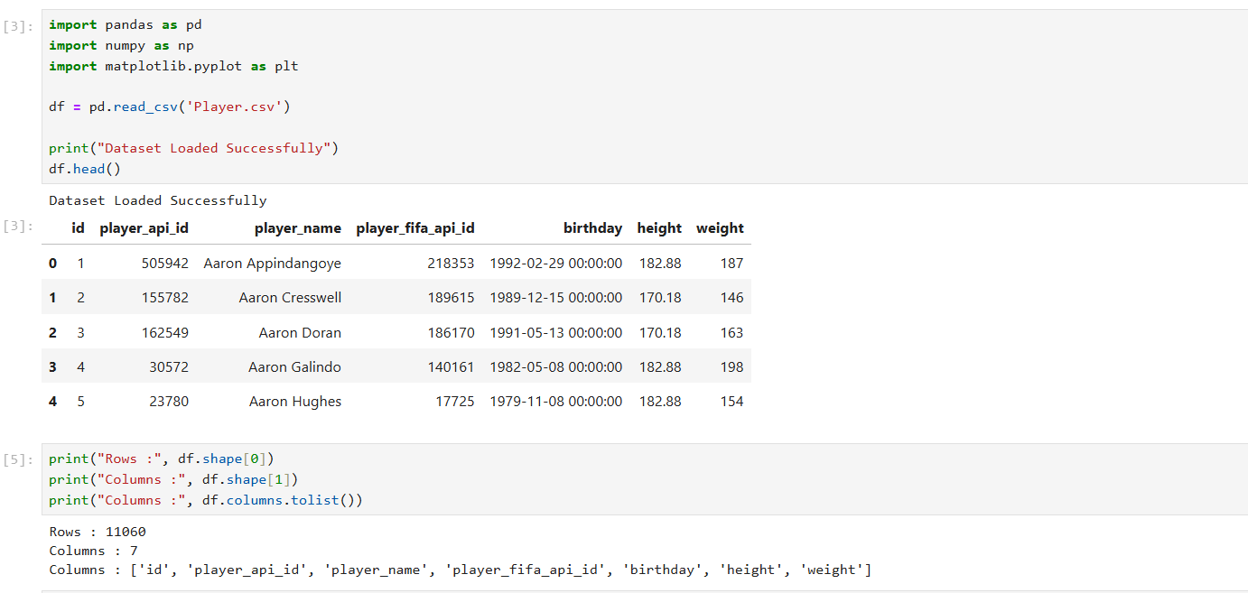
• Import the required libraries
• Load the Player dataset
• Display rows, columns and column names

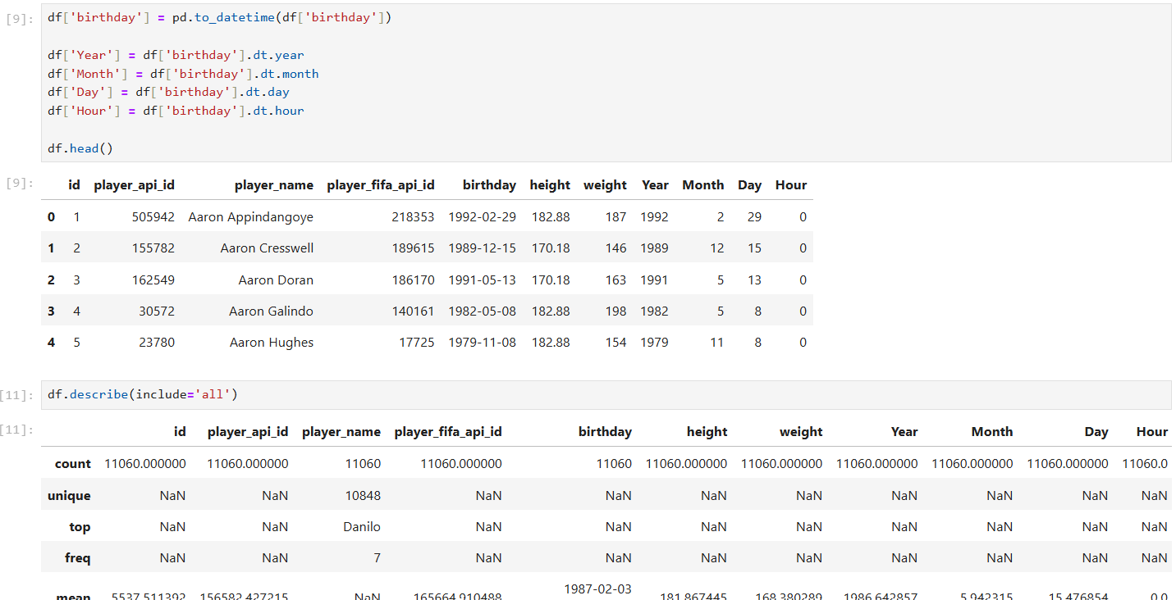
• Display data types
• Convert birthday to datetime and extract Year, Month, Day and Hour

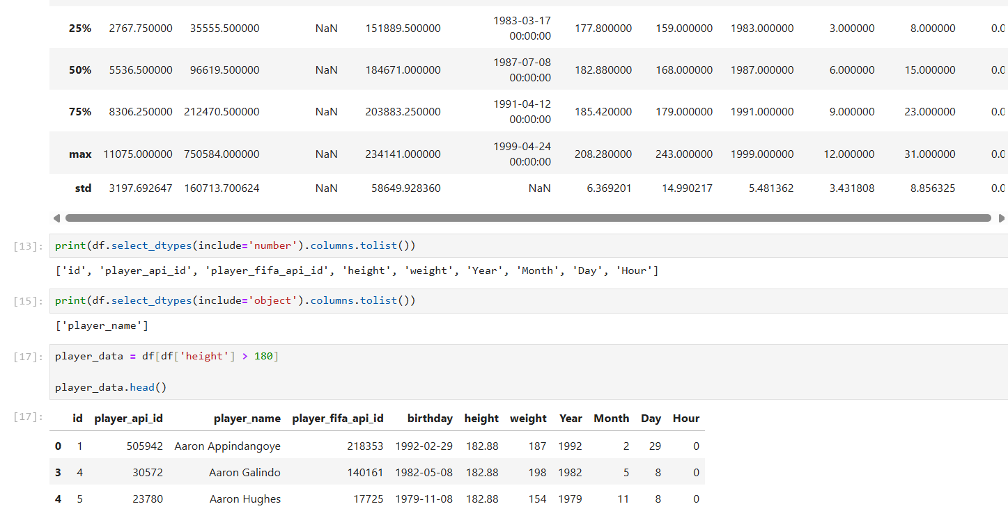
• Display data types
• Convert birthday to datetime and extract Year, Month, Day and Hour
• Statistical Summary

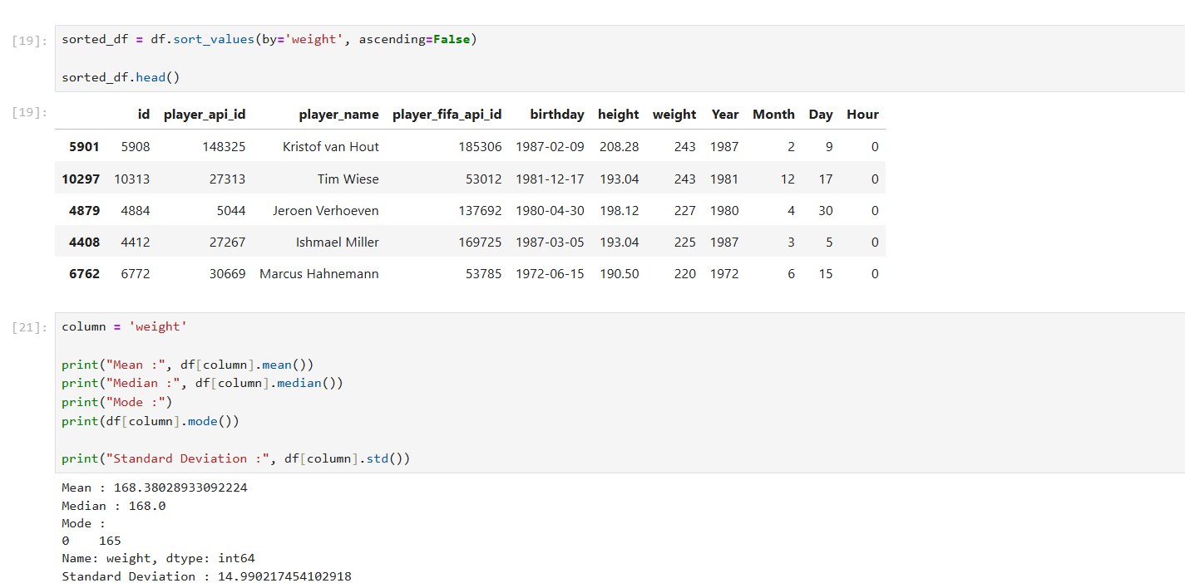
• Display Numerical Columns
• Display Categorical Columns
• Filter players based on height

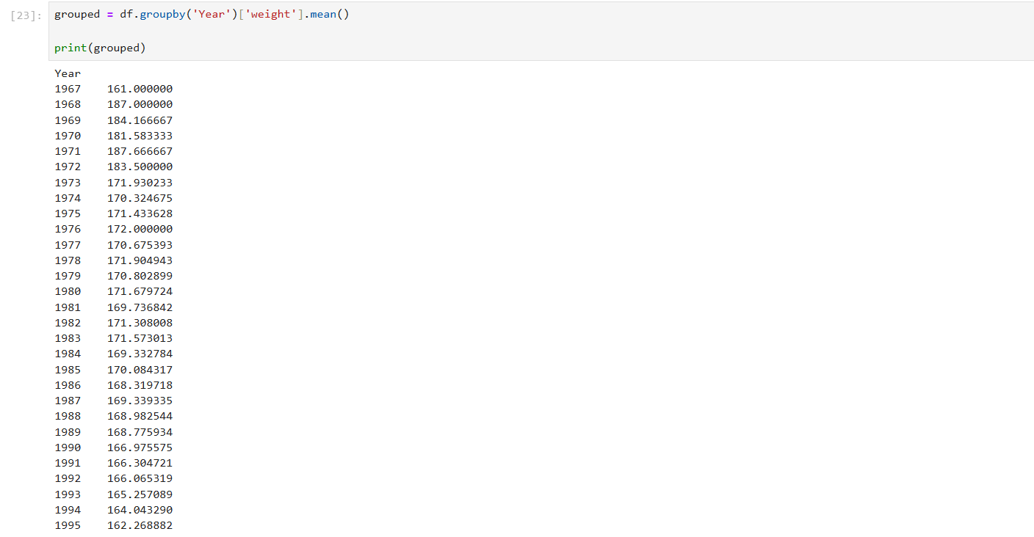
•Sort Dataset
• Mean, Median, Mode and Standard Deviation is found out
•Grouping and Aggregation is made

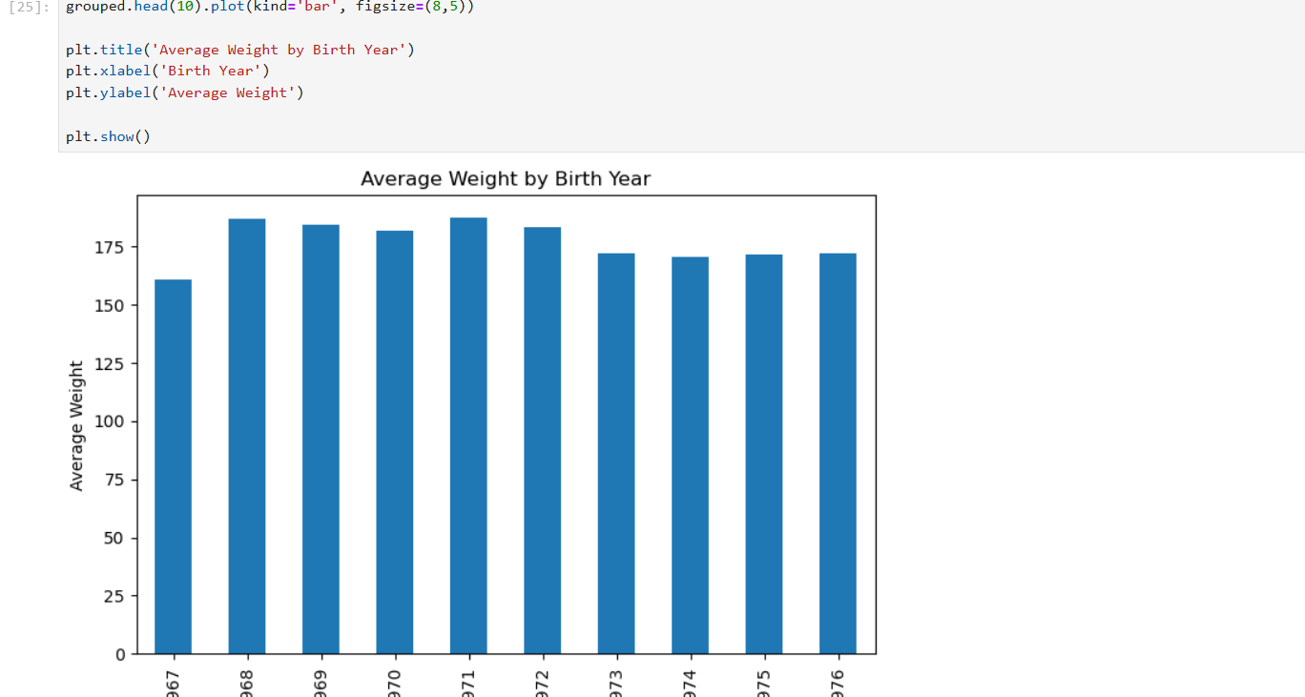
• Bar Chart is ploted

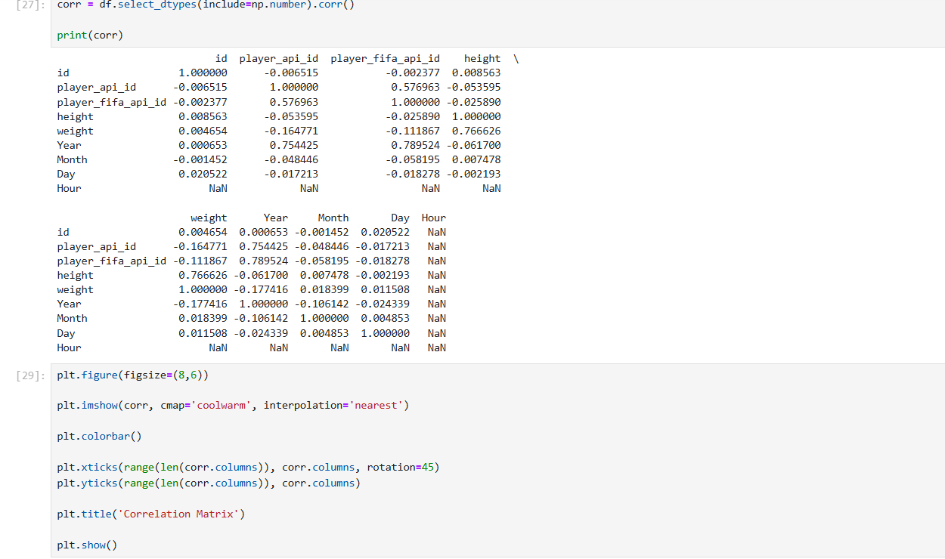
• Correlation Matrix is created

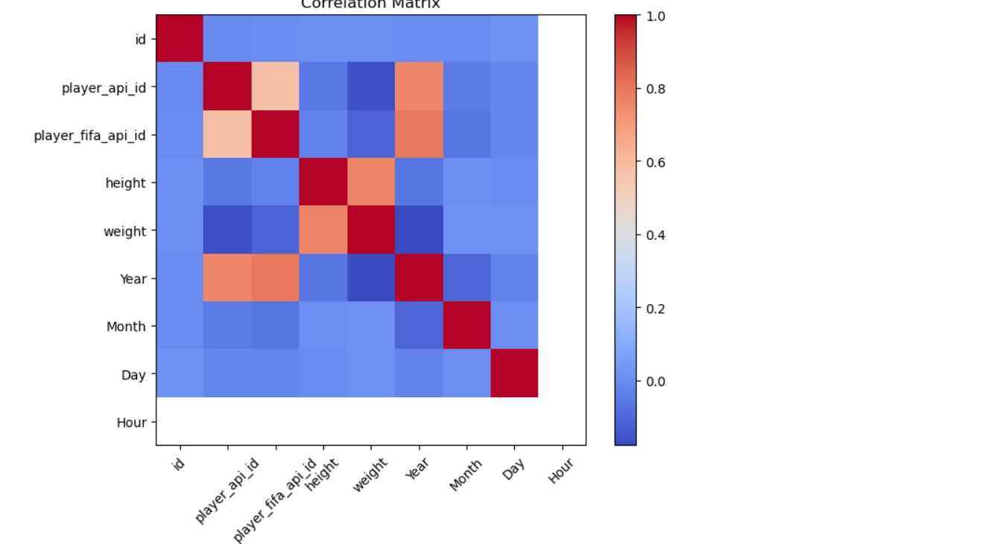
• Correlation Heatmap is ploted

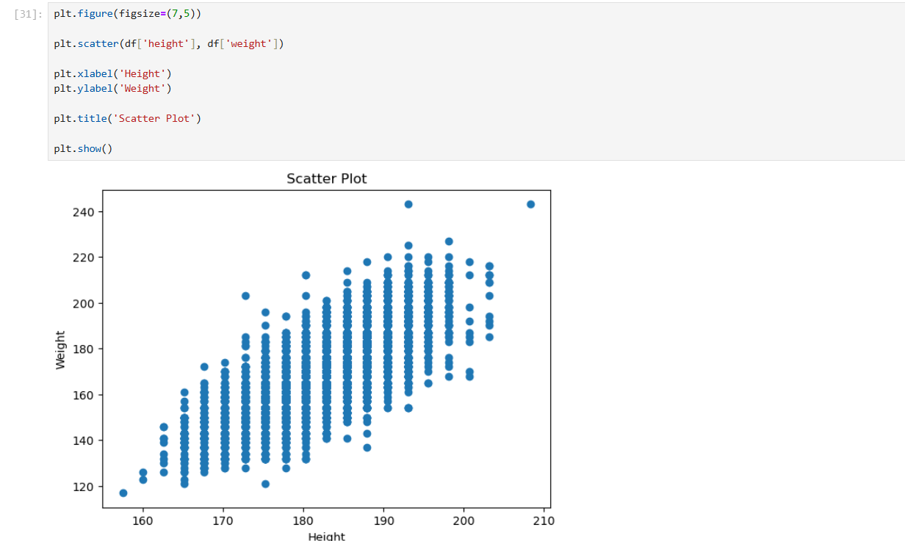
• Scatter Plot the dataset

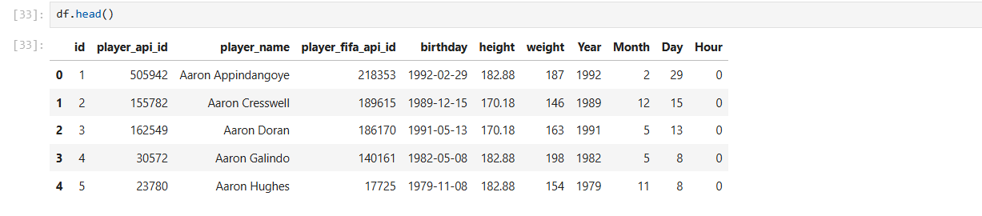
• Final Dataset is displayed

